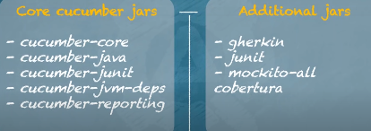

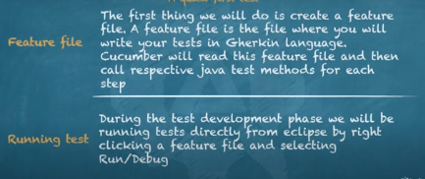

Demo 1:

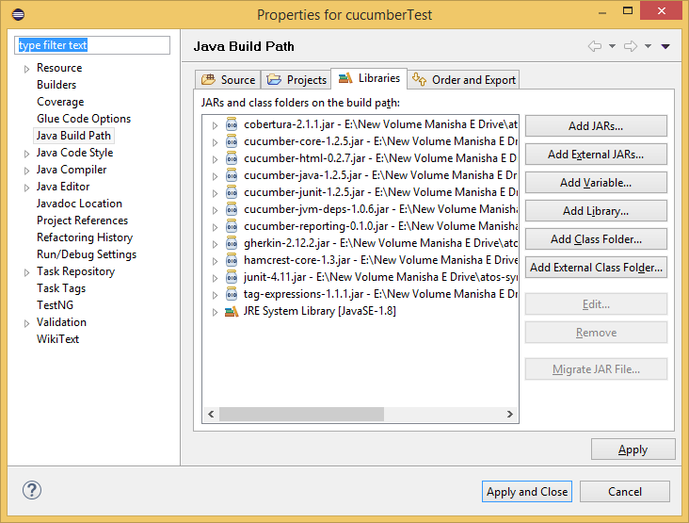

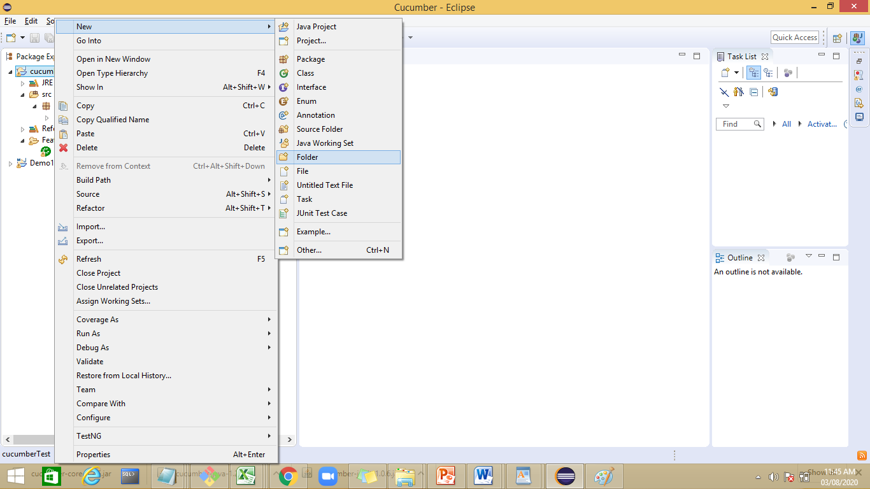

Create a folder with name Feature

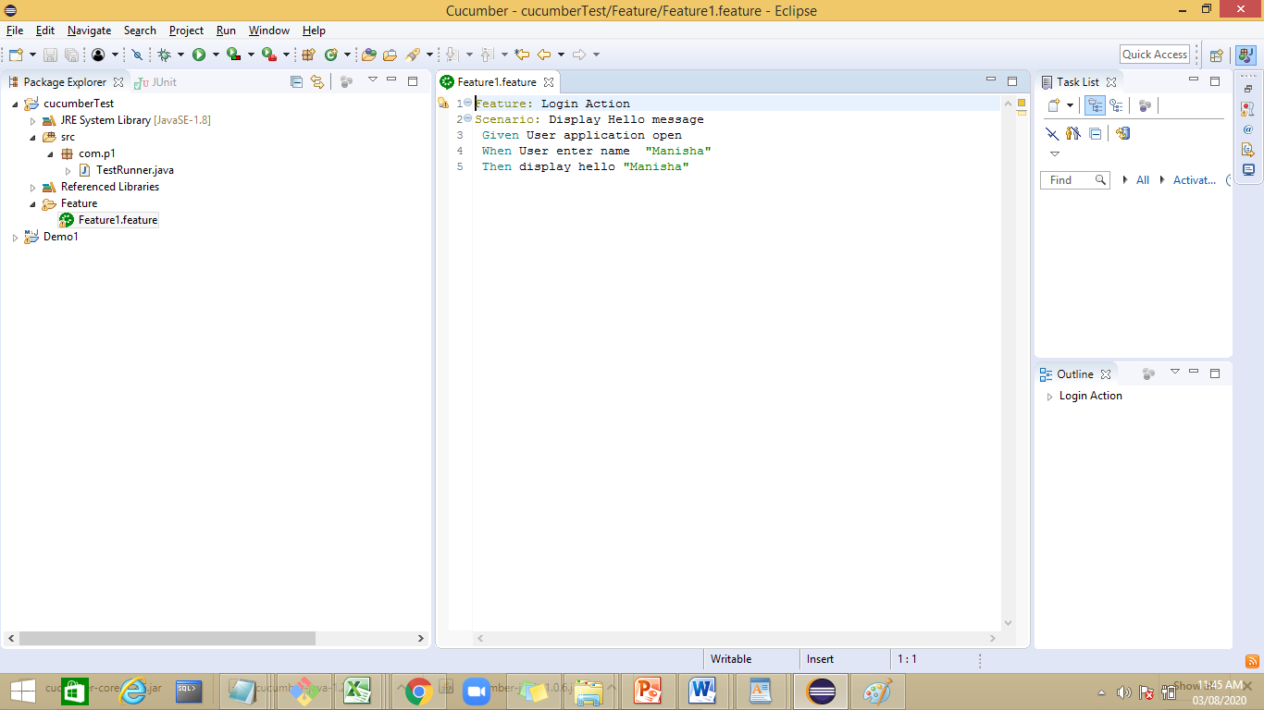

Feature: Login Action

Scenario: Display Hello message

Given User application open

When User enter name

Then display hello

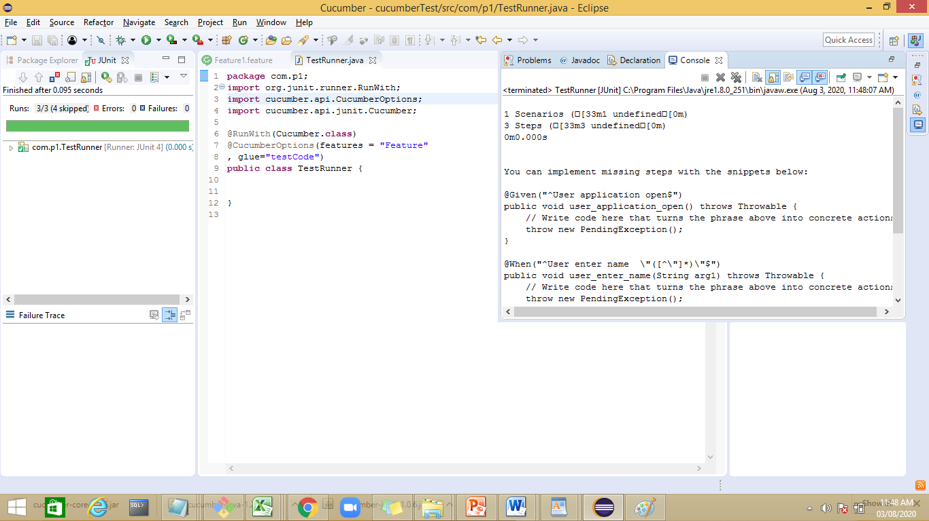

**package** com.p1;

**import** org.junit.runner.RunWith;

**import** cucumber.api.CucumberOptions;

**import** cucumber.api.junit.Cucumber;

@RunWith(Cucumber.**class**)

@CucumberOptions(features = "Feature"

, glue="com.step")

**public** **class** TestRunner {

}

Demo2:

Cucumber test add a step file with name HelloStep

**package** com.step;

**import** java.util.Scanner;

**import** cucumber.api.java.en.Given;

**import** cucumber.api.java.en.Then;

**import** cucumber.api.java.en.When;

**public** **class** HelloStep {

String name;

@Given("^User application open$")

**public** **void** User_application_open()

{

System.***out***.println("In user Application");

}

@When("^User enter name$")

**public** **void** User_enter_name ()

{

Scanner sr=**new** Scanner(System.***in***);

name=sr.next();

}

@Then("^display hello$")

**public** **void** display_hello()

{

System.***out***.println("Hello"+name);

}

}

**package** com.p1;

**import** org.junit.runner.RunWith;

**import** cucumber.api.CucumberOptions;

**import** cucumber.api.junit.Cucumber;

@RunWith(Cucumber.**class**)

@CucumberOptions(features = "Feature"

, glue="com.step")

**public** **class** TestRunner {

}

Output:

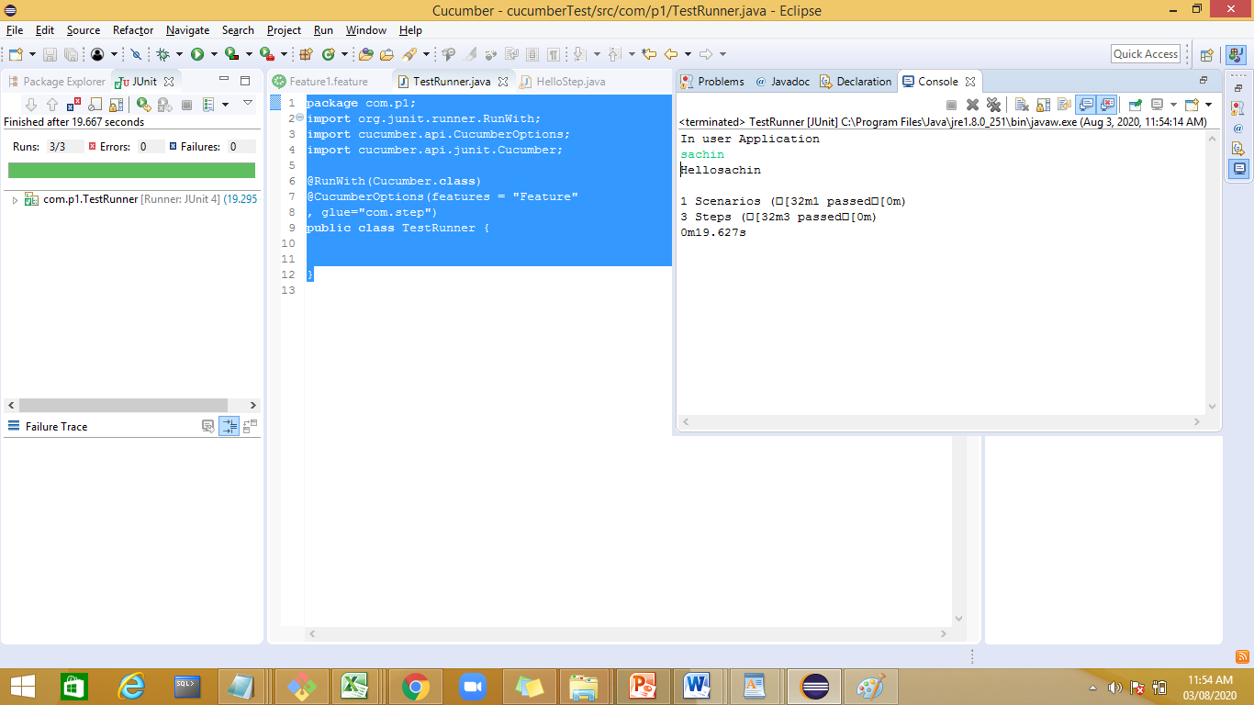

Naughty